# ***Challenge Name :- XSS Catacombs***

**Description:** Welcome to the depths of the XSS Catacombs, where unseen dangers lie dormant. Venture forth into the heart of a PDF-to-image conversion system, where shadows conceal hidden threats. Can you navigate the labyrinthine passages and unearth the flag without alerting the vigilant guardians

**Level:** Medium

**Solution: :**

**Step 1:** You will see a pdf to image and image to pdf web application.

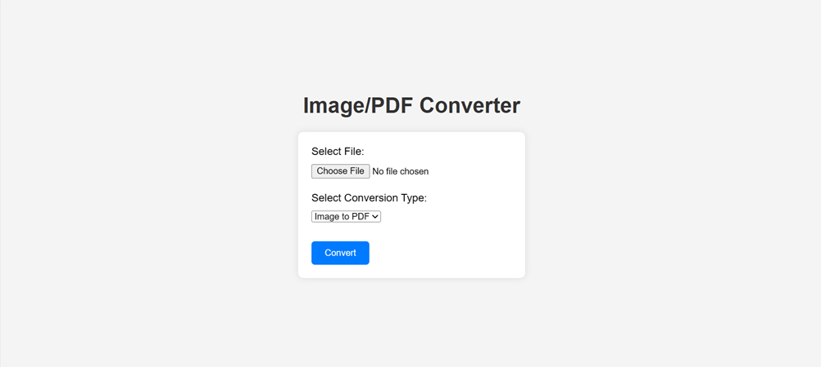

**Step-2:** You have to put xss payload in pdf anywhere in heading and content and try to convert.

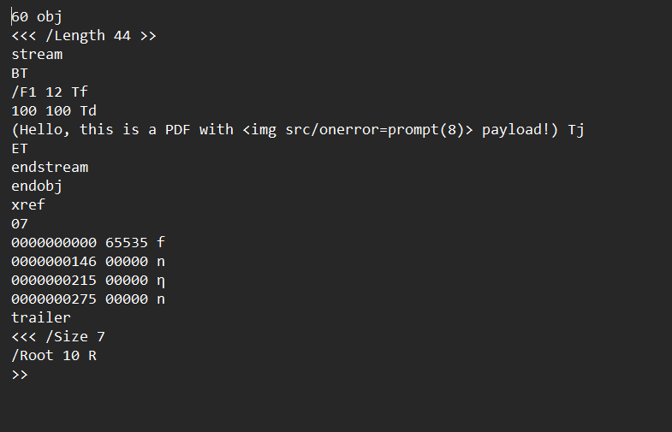

You will see these type message because of regex , which detecting the xss payload.

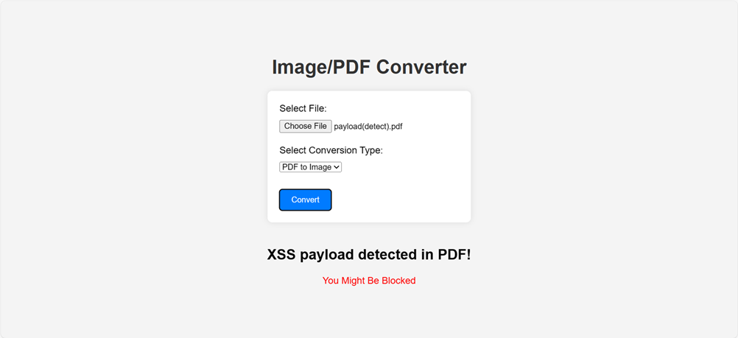

**Step-3:** You have to put some valid payload and check by hit and try , Here work only payload which have img tag like <img src/onerror=prompt(8)> After that you will see the flag.

**Payload:**<img src/onerror=prompt(8)>

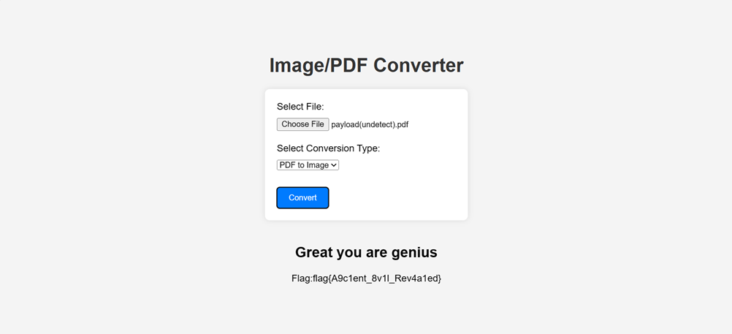

**Flag:** flag{A9c1ent_8v1l_Rev4a1ed}

This page is intentionally left blank